**Testing and Refactoring**

**Service Tests:** All the service tests passed the first time.

**Controller Tests:** Tests failed as ISBN Number was too long of a number to store in MySQL Database.

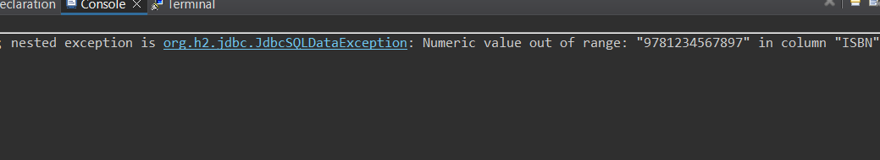

**Refactor:** To fix this I changed the datatype into a string but since a String can slow down the performance of MySQL if used as a primary key I created a new column bookId and auto-incremented it to use as a primary key instead.

**+** Added changes to service test since the I made changes to the interfaces and classes and all the tests still pass.

**Controller Tests:** All the tests passed after this change was implemented

**Custom Query:**

After all my code tests were running I decided to add a custom query that if a book was created that already existed than it would just add 1 to the quantity of the existing book so as to reduce redundant data.

**Service & Controller Tests:** When the tests were ran it added 1 to the quantity of the book f it existed but also 1 to the quantity when it created a new book.

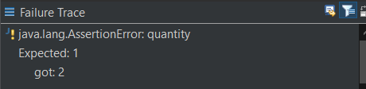

**Refactor:** I added in some brackets to clarify the if else and moved and adjusted some of the code which resolved the issue of adding a new book. However now the opposite problem happened when the same book is entered it just created a new record.

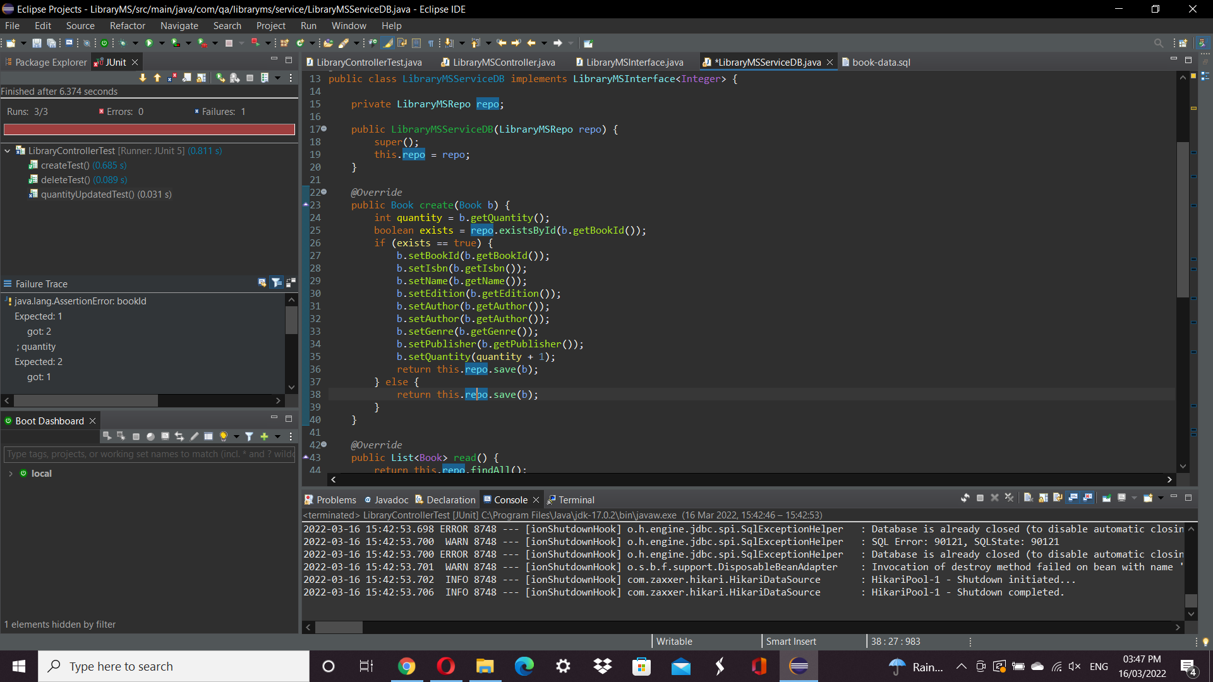

**Refactor:** I readjusted the code and tried moving the part which changes the quantity into its own method that is only called when the book entered already exists.

**Service & Controller Tests:** When I ran the tests it produced a stack overflow error.

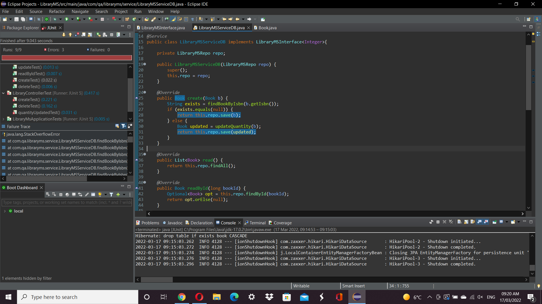

**Refactor:** I changed to try to check for null which got rid of error but still produced a new record when the book existed instead of adding 1 to the quantity so I tried deleting the old record and replacing it with the new to solve that issue

**Service & Controller Tests:** This change did not change the outcome as the delete statement would not run.

**Issues:** When I went back to check my other postman requests some of them were not working so since time was short I decided to remove the quantity query that I had implemented so that the other required functions could still work.